Social Studies 20-1

Related Issue 3

To what extent should internationalism be pursued?
Written Response

SENIOR HIGH SCHOOL
Fort Saskatchewan 780 992 0101
Sherwood Park 780 464 1899
Vegreville 780 632 7998

Social Studies 20-1 Writing Assignment I (15 marks)

Suggested time: 30-45 minutes
Examine all three sources. Write a response in paragraph form in which you:
- interpret each source, explain the perspective(s) presented, and discuss the links between [globalization, nationalism or liberalism] and each source,
AND
- identify and explain one or more relationship(s) that exists among the sources

Source I

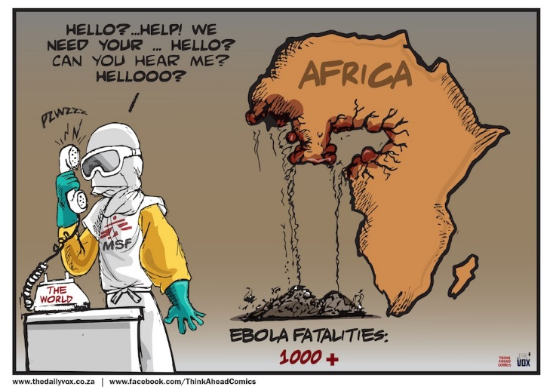

Source II
No country can afford to deal with today’s threats alone, and no threat can be dealt with effectively unless other threats are addressed at the same time.
Kofi Annan, former U.N. Secretary-General (2004)
Source III
Our country is not the only thing to which we owe our allegiance. It is also owed to justice and to humanity. Patriotism consists not in waving the flag, but in striving that our country shall be righteous as well as strong. ~James Bryce

Your response will be evaluated on how effectively you:
- interpret and explain each source and the perspectives they reflect, and discuss the links between each source and nationalism//internationalism (7.5 marks)
- identify and explain the relationship(s) that exist among the sources (5 marks)
- communicate your ideas using appropriate vocabulary, sentence structure, organization, mechanics and grammar (2.5 marks)

